Project Instructions: NovaTech Revenue Intelligence Dashboard
NovaTech Solutions is a B2B SaaS company whose revenue data lives in three separate systems: CRM deals, marketing campaigns, and support tickets. VP of Revenue Operations Sarah Chen has asked you to unify these into a single Revenue Intelligence Dashboard so her team can spot revenue trends, identify at-risk accounts, and make faster decisions.
Your workspace includes pre-indexed knowledge bases (created by the instructor), three CSV starter files, a data dictionary, a company background brief, and Sarah Chen's dashboard requirements brief. Read all three reference documents before you begin.
Building unified analytics dashboards from siloed data sources is a core responsibility for BI analysts — this project mirrors the exact workflow you would follow when joining a new team and being asked to consolidate reporting across multiple business systems.
Collect Screenshots
As you complete the following project tasks, make sure to collect screenshots from the Submission Deliverables section below to submit.

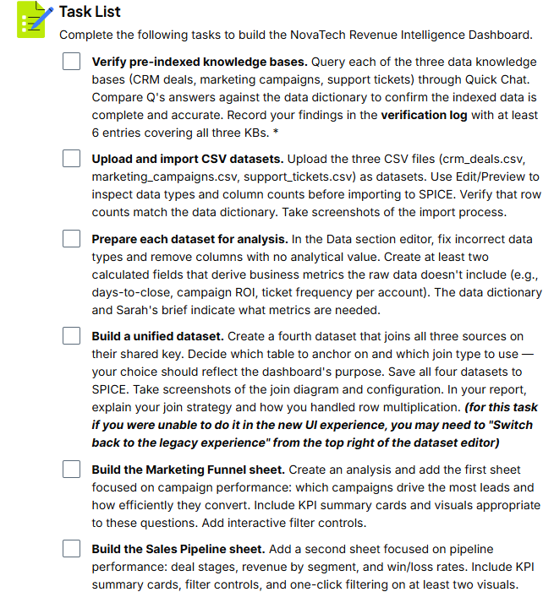

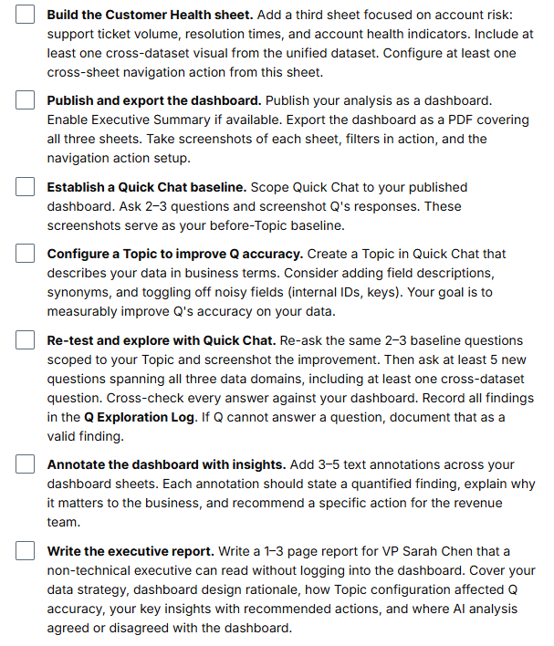

Verify Your Implementation
Before submitting, walk through these verification scenarios to confirm your work is complete.
Verification 1 — Data completeness Open each of your four datasets and confirm the row counts and column counts match your expectations. The unified dataset should have more rows than any individual source (due to joins). If the row count seems unexpectedly high, review your join type and consider whether fan-out is occurring as expected.
Verification 2 — Dashboard interactivity Open your published dashboard. On each sheet, apply a filter and confirm the visuals update. Click a data point to trigger one-click filtering on a second visual. Use the cross-sheet navigation action and confirm it takes you to the correct sheet.
Verification 3 — Quick Chat accuracy Open Quick Chat scoped to your Topic. Ask a question you know the answer to from your dashboard (e.g., "What is the total revenue from closed-won deals?"). Compare Q's answer to the KPI on your Sales Pipeline sheet. They should agree or you should be able to explain the discrepancy.
Verification 4 — Report completeness Review your executive report against the requirements: Does it cover data strategy, design rationale, Topic configuration effects, key insights with actions, and AI vs. dashboard comparison? Can a non-technical reader understand it without logging in?
Verification 5 — Annotation quality Review your dashboard annotations. Each should go beyond restating the chart title — it should include a specific number, a business explanation, and a recommended action.
Submission Checklist
Before submitting, confirm you have included all of the following:
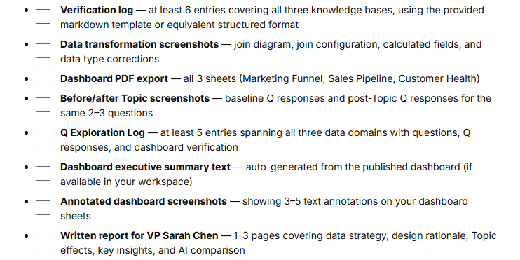

Rubric
Use this project rubric to understand and assess the project criteria.
Data Preparation & Quality
Criteria | Submission Requirements
Verify data quality and completeness across indexed knowledge bases | - Verification log contains at least 6 entries covering all three data knowledge bases (CRM deals, marketing campaigns, support tickets)  - Each log entry includes a natural language question, Q's response, the expected answer from the data dictionary, and a pass/fail assessment  - Verification log questions target checkable facts such as row counts, distinct values, date ranges, or known null counts  - Screenshots show all three CSV datasets successfully imported into SPICE with correct row counts and column counts
Transform and join datasets using no-code data preparation tools | - Screenshots show data type corrections applied to at least one dataset  - At least two calculated fields use business logic (e.g., days-to-close, campaign ROI, ticket frequency)  - A unified dataset joins all three data sources on a shared key, with the join diagram and join configuration visible in screenshots  - Screenshots or report text identify the anchor table and join type used for the unified dataset  - All four datasets (three source + one unified) are saved to SPICE
Dashboard Design & Interactivity
Criteria | Submission Requirements
Design and build a multi-page interactive dashboard for business decision-making | - Dashboard contains three sheets: Marketing Funnel, Sales Pipeline, and Customer Health  - Each sheet includes at least one KPI summary card and multiple visualizations appropriate to the business questions  - The Customer Health sheet includes at least one visual built from the unified (joined) dataset  - At least two sheets include interactive filter controls  - At least one sheet includes a one-click filtering action on two or more visuals  - At least one cross-sheet navigation action links between sheets  - Dashboard is published and exported as a PDF covering all three sheets
AI-Powered Analysis & Communication
Criteria | Submission Requirements
Configure and use AI-powered natural language querying to explore data | - Screenshots show baseline Quick Chat interaction (2–3 questions asked before Topic configuration)  - A Topic is configured, and screenshots show the Topic setup  - Post-Topic screenshots show the same 2–3 baseline questions re-asked with improved or changed responses  - Q Exploration Log contains at least 5 entries spanning all three data domains, including at least one cross-dataset question  - Each log entry includes the question asked, Q's response, and verification against the dashboard
Extract and communicate data-driven business insights to stakeholders | Dashboard includes 3–5 text annotations visible on the dashboard sheets  - Each annotation states a quantified finding, a business implication, and a recommended action  - Written report for VP Sarah Chen is 1–3 pages and covers: data strategy, dashboard design rationale, how Topic configuration affected Q accuracy, key insights with recommended actions, and where AI analysis agreed or disagreed with the dashboard  - Report defines technical terms on first use, contains no raw SQL or formulas, and uses complete sentences
Suggestions to Make Your Project Stand Out
- Add a predictive or trend analysis sheet — Create a fourth dashboard sheet that uses QuickSight's forecasting or trend line features to project future revenue, deal closure rates, or support ticket volume. Explain the assumptions behind your forecast in annotations.
- Build a custom Topic with semantic layer enrichment — Go beyond basic Topic configuration by adding comprehensive field descriptions, business term synonyms, and named filters. Test Q with progressively complex questions and document how each enrichment improved accuracy.
- Personalize the scenario to your own domain — Replace the NovaTech scenario with data from your own industry or role. Use publicly available datasets (e.g., Kaggle) to build a dashboard that solves a real problem you face at work. Document how the skills from this project transfer to your chosen domain.

Collect all of your project files and compress/zip them. Submit the zip file here.
Before submitting, check the Rubric on the previous page to make sure your project meets all of the submission criteria.
Before submitting, confirm you have included all of the following in your zip file:
- Verification log — at least 6 entries covering all three knowledge bases, using the provided markdown template or equivalent structured format
- Data transformation screenshots — join diagram, join configuration, calculated fields, and data type corrections
- Dashboard PDF export — all 3 sheets (Marketing Funnel, Sales Pipeline, Customer Health)
- Before/after Topic screenshots — baseline Q responses and post-Topic Q responses for the same 2–3 questions
- Q Exploration Log — at least 5 entries spanning all three data domains with questions, Q responses, and dashboard verification
- Dashboard executive summary text — auto-generated from the published dashboard (if

Ill plan to use the public git repo for subission

